Azure DevOps PIPELINE

1.Select Repo for Exp iAgriOps. Create Pipeline.

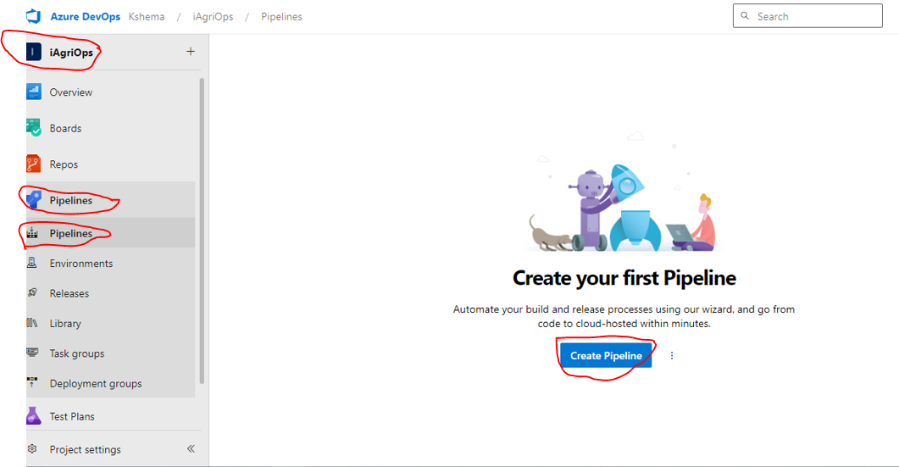

2. Select AzureRepo

3.Select Repository as shown below.

4.select here new pipeline (Starter Pipeline), if we have existed yaml then select existing pipeline.

5.here we have two type of pipeline if we select classic pipeline the code will automatically generate, then copy the code and paste in normal yaml file create the stracture.